DQL 3

- Display the employee names and department names of all the employees working in the job type Salesman and Analyst

- Display the following report.

ENAME DEPARTMENT NAME
---------- ------------------------------
SMITH SMITH works in RESEARCH
ALLEN ALLEN works in SALES
WARD WARD works in SALES
JONES JONES works in RESEARCH
MARTIN MARTIN works in SALES
BLAKE BLAKE works in SALES
CLARK CLARK works in ACCOUNTING
SCOTT SCOTT works in RESEARCH
KING KING works in ACCOUNTING
TURNER TURNER works in SALES
ADAMS ADAMS works in RESEARCH
JAMES JAMES works in SALES
FORD FORD works in RESEARCH
MILLER MILLER works in ACCOUNTING

- Display the highest salary for each job within each department as per the following report –

Department JOB Highest Sal
-------------- --------- -------------------------------------
ACCOUNTING CLERK 1300
ACCOUNTING MANAGER 2450
ACCOUNTING PRESIDENT 5000
RESEARCH ANALYST 3000
RESEARCH CLERK 1100
RESEARCH MANAGER 2975
SALES CLERK 950
SALES MANAGER 2850
SALES SALESMAN 1600

9 rows selected.

4. Display employee name, department name, location and job for all employees of MANAGER job having salary above 2900.

- Display the name of the employees reporting to KING.

- Display the count of employees reporting to KING.

- Produce the following output –

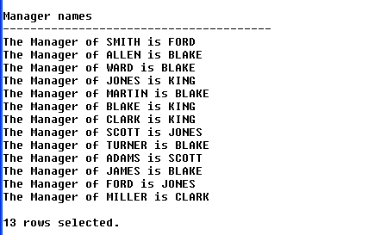

Copy-Paste the following script about Flight Schedule in your schema –

Drop Table Customers;
Drop Table Flights;

create table customers(CustId int Primary Key, CustName varchar(40), FlightNo int Not Null);
create table flights(FlightNo int Primary key, GateNo char(3) Not Null, FlightName varchar(40), Status varchar(100), Route Varchar(100));

Insert Into Customers Values(1,'a',123);
Insert Into Customers Values(2,'b',456);
Insert Into Customers Values(3,'c',123);
Insert Into Customers Values(4, 'd',456);
Insert Into Customers Values(5, 'e', 789);
Insert Into Customers Values(6, 'f', 123);
Insert Into Customers Values(7, 'g', 456);
Insert Into Customers Values(8, 'h', 789);
Insert Into Customers Values(9, 'i', 456);
Insert Into Customers Values(10, 'j', 123);
Insert Into Customers Values(11, 'k', 125);
Insert Into Customers Values(12, 'l', 456);
Insert Into Customers Values(13, 'm', 789);
Insert Into Customers Values(14, 'n', 124);
Insert Into Customers Values(15, 'o', 125);
Insert Into Customers Values(16, 'p', 126);
Insert Into Customers Values(17, 'q', 125);
Insert Into Customers Values(18, 'r', 126);
Insert Into Customers Values(19, 's', 127);
Insert Into Customers Values(20, 't', 127);

Insert Into Flights Values('123', 'G1', 'Spice Jet', 'Departure On Time', 'Pune-Delhi');
Insert Into Flights Values('456', 'G2', 'Indigo', 'Departure Late by 45 Minutes', 'Pune-Hyderabad');
Insert Into Flights Values('789', 'G1', 'Jet Lite', 'Departed', 'Pune-Bangalore');
Insert Into Flights Values('124', 'G3', 'Indian Airlines', 'Arrival late by 30 Minutes', 'Chennai-Pune-Baroda');
Insert Into Flights Values('125', 'G4', 'King Fisher', 'Departure On Time', 'Pune-Kolkata');
Insert Into Flights Values('126', 'G7', 'King Fisher', 'Departure On Time', 'Pune-Chandigad');
Insert Into Flights Values('127', 'G9', 'Air Deccan', 'Departure On Time', 'Pune-Chandigad');

Following 2 commands to be executed only in SQL Plus editor

col status format a30
col route format a30

- Display the names of the customers who are going to depart on time.
- Display the names of those customers who are not flying from Pune to Bangalore
- Display the names of those customers who all are going from Gate number 1.
- Display the names of those customers who are going to Chandigad through King Fisher airlines only.

Copy-Paste the following script about Billing Cycle in your schema –

create table Customer_Details
(CustId Char(3), CName Varchar(20));

create table Payment_Details
(CustId Char(3), PaymentId char(3), Amount Int, Status varchar(20));

Insert Into Customer_Details Values('C1', 'John');
Insert Into Customer_Details Values('C2','Roger');
Insert Into Customer_Details Values('C3','Smith');
Insert Into Customer_Details Values('C4','Martin');
Insert Into Customer_Details Values('C5','Luther');
Insert Into Customer_Details Values('C6', 'King');
Insert Into Customer_Details Values('C7','Allen');

Insert Into Payment_Details Values('C1', 'P1', 35000, 'Paid');
Insert Into Payment_Details Values('C3','P2',80000,'Paid');
Insert Into Payment_Details Values('C16','P3',90000,Null);
Insert Into Payment_Details Values('C6','P4',10000,'Paid');

- Generate the following report –

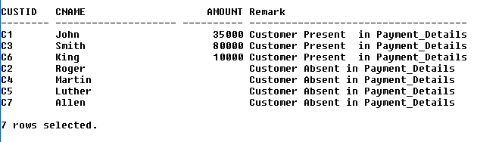

- Display the customer id customer name, status and amount of the customers who have paid as well as those who have not paid.

